**Burning Glass**

**Individual Bio:**

The ideal job and career for our group is varied, and the preferred / ideal career would be in areas such as from an IT analyst to software developer, IT Management and even a Policy Officer which has very little to do with IT. The following is a brief description of our group’s ideal role and field once we graduate from our current studies:

Samuel Jones – The preferred job is for a software developer / engineer with sufficient knowledge on coding languages such as: C#, Python and JavaScript. The required / desired database language is PHP, ASP.net, SQL coding, and the role requires a Bachelor of Science or similar. The required traits for the potential employment include: Excellent Communication skill, Presentation skills, problem solving and analytical skills and a team player. Samuel currently has experience and some exposure to Python and Javascript.

Jacob Smith – The preferred job is for a Business Information Systems Analyst and the preferred knowledge is on Microsoft Office, CRM, Microsoft Power platform like Dynamics 365, Lean Six Sigma, Virtualisation and database analyst including update. A minimum of Bachelor’s Degree is essential in the relevant area and traits preferred for potential employment include: Problem Solving skills, analytical, ability to multi-task, meeting deadlines and be able to prioritise. Jacob has an interest in IT and have always had great ideas on the application he wants to make. His skills include building a robust website and has some knowledge on information systems and coding.

Scott Smith – The ideal role for Scott is in the field of IT Management, Project leader and the preferred skills and knowledge include IT troubleshooting, ICT systems, Customer Excellence in maintaining systems, Windows SOE, Application Packaging in service and patching. The traits needed for the role include: Analytical skills, able to work under pressure, manage staff and organising skills. Scott’s past experience include working for the ARMY before entering the IT sector. Scott has a wealth of knowledge and skills in the IT sector and currently employed in the IT field. Scott has undertaken further studies to broaden and deepen his IT Systems skills and eventually want to migrate to the field of Applications Packaging and testing stages of packages.

Kim Ve Jong – The ideal role for Kim is in the field of Policy for the Public sector. The skills needed for Policy is the understanding of Policy cycle, current legislation, departmental budget, Microsoft packages, understand the criteria and objective, prepare report for presentation and formulate advice. The traits needed for the policy role include analytical skills, problem solving, research, knowledge on current policy and legislation including law, being able to work under pressure and meeting scheduled deadline. With Kim Ve’s current studies in the relevant field for Public Service, the degree has positioned Kim to pursue the role of Policy worker.

**Ideal Jobs – Group’s Core Skill Requirements**

Based on our group’s desired career choice and our ideal paths that we all want to forge, we have identified our group’s core requirement:

Communication

Problem solving

Analytical skills

Time management

We all need to possess these core skills and do really well to succeed in our chosen career path, as these skills will be assessed, analysed, being judged upon, and form the basis of an impression. These four skills when forming a team for collaboration is a definite must, as failing to do so will ultimately break down, nothing gets done and over budget to cover these shortfall. The team will also get disgruntled, for example, the group or a member of the group has poor time management skills and ultimately the project has not been completed by the scheduled time, and well, leave it to the (ether, it will sort itself out (the marker will sort it out!!)). Contrary to this notion, if the group embraces these four core skills, it is a recipe for success.

However, each of our group member also has a unique subset skill that is suitable and curated for their role more specifically. They are:

Presentation Skills – Samuel Jones – A unique set of subset skills required for the ideal job. This is very important because presentation in terms of powerpoint slides, dress code and grooming will set an impression, including an impression of the work. Even the way Samuel codes will need to have a proper structured coding that makes much more readable and not look like spaghetti style coding. So presentation skills for Samuel is a must.

Multi-tasking – Jacob Smith – The role of Information systems analyst may need to wear a different hat here and there, by the project being analysed. There may be multiple projects happening at the same time and applying efficiency by using a suite of applications for tracking, analysing, estimate, costing, resources and much more indeed does require multi-tasking and delegation. An example of requiring the knowledge of lean six sigma is a testament to the importance of multi-tasking.

Leadership – Scott Smith – The ideal role of IT Management / Leadership is leadership skills to guide and mentor staff to meet the objective requirement set by the organisation. Scott may need to wear different hats everyday, such as mentoring staff, sensitive conversation, meeting with upper management or a meting with the group. As management, Scott also needs to possess customer excellence to retain external stakeholders, customers and clients to ensure the well being of the organisation.

Research – Kim Ve Jong – As an ideal work in the policy in the public sector, research is paramount to understand and articulate the formulation of policy or an update to policy change. There are so many components that make up policy, such as legislation, law from each states, political climate, data, and knowledge is essential component. However, research skills play a crucial role in policy because it ensures that policy drafted is well refined and has been researched thoroughly covering aspects that is meant to be covered.

Below are the core skills requirement from Burning Glass data encapsulating our group’s core skills and our unique subset skill in demand of the industries.

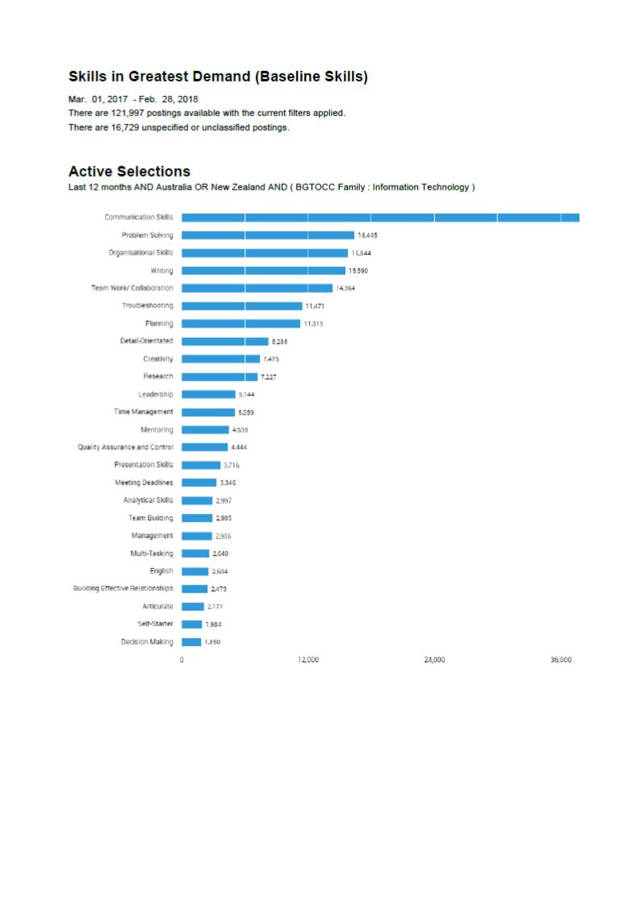

When delving further to analyse the composition of the labour market in terms of industry types, IT is well suited in many sectors of the Australian industry, as each sector will depend on their IT systems to run their core business. With Kim Ve’s policy style of work however, it may well be suited for most industries, as policy ACT govern and regulate industries by setting the parameters on how they should operate. Below are the graph that shows the major industries in Australia by the Department of Jobs and Small Business:

[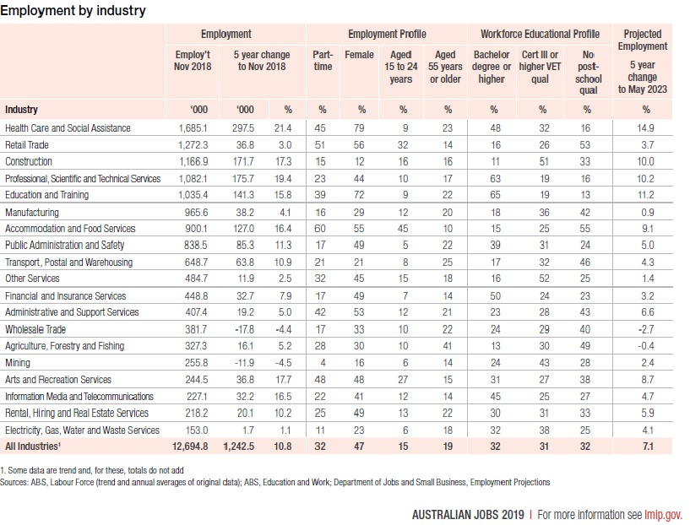https://docs.employment.gov.au/system/files/doc/other/australianjobs2019.pdf](https://docs.employment.gov.au/system/files/doc/other/australianjobs2019.pdf) on page 13.

Furthermore, the top job types in Australia data collected from the Department of Jobs and Small Business reveal the core role and positions filled in the Industry. For example the position of software and applications developer has around 123 thousand employed in that field and the ANZSCO code is 2613. Below are the graph for the team’s desired role encapsulated in the occupation matrix from the Department of Jobs and Small Business:

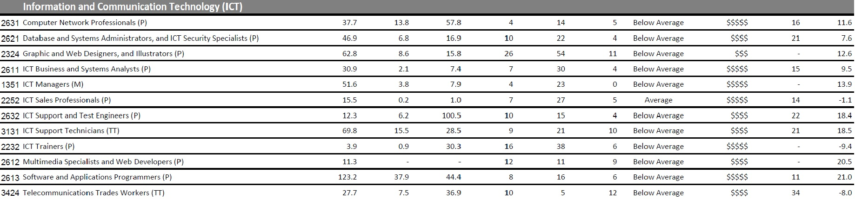

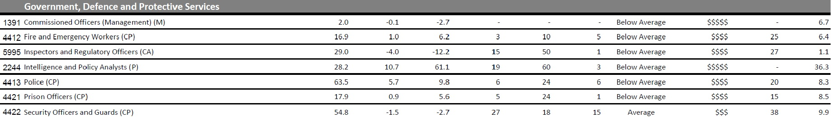

<https://docs.employment.gov.au/system/files/doc/other/australianjobs2019occmatrix.pdf>

Three Highest ranked skills not listed in our group:

Based on the data provided on Burning glass data, the three highest skills not listed in our group is organisational skills, writing and planning. However, the core skill requirements that our group has identified would be able to cover these areas adequately and with an additional member David in our team recently, we have expanded our capabilities and resource sharing.

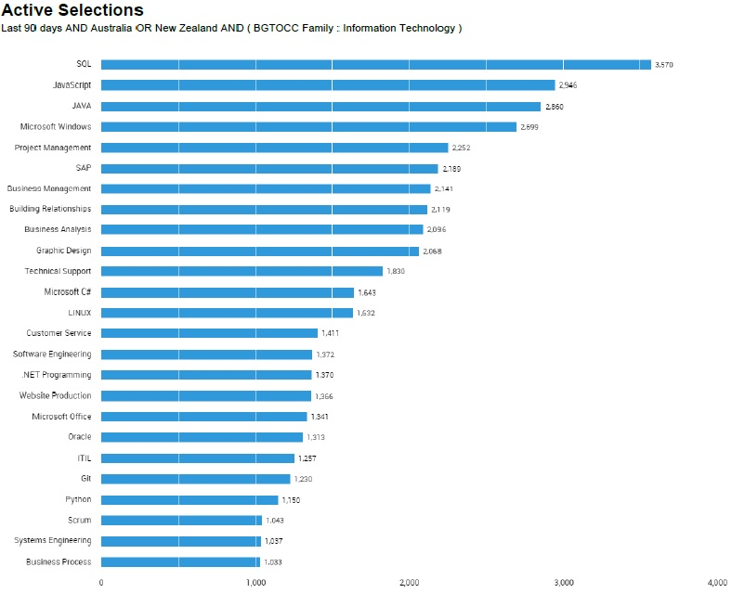

From the list of IT skills in highest demand and not in our groups list are Graphic Design, SAP and Javascript. Although Kim Ve’s preferred policy role has very little to with specific IT software and hardware platform, it means these skills will covered by the other team members and minimising this capability gap.